SIMATS ENGINEERING
SAVEETHA INSTITUTE OF MEDICAL AND TECHNICAL SCIENCES
CHENNAI – 602105
Department of Computer Science and Engineering

ASSESSMENT TOOL 2 – SCHEMA ANALYSIS AND VIVA VOCE

Course Code: | DSA05 | Course Title: | Query Processing for Data Science With Real Time Applications
CO Assessed: | CO2 | Assessment: | Tool 2 – Schema Analysis and Viva Voce
Weightage: |  | Total Marks: | 20 Marks
CO2 Statement: Use Python basics and SQL libraries to connect to databases SQLite, MySQL, PostgreSQL and perform CRUD operations like Create, Read, Update, Delete. (BTL6)
Student Name: | K. V. Sai. Shanmukh | Reg. No.: | 192424306
Section / Batch: | BTECH-AI & DS | Date of Submission:
Faculty In-charge: |  | Project Mode: | Individual Submission

Code of Conduct
I _K. V. Sai. Shanmukh(192424306) (Name / Reg No) certify that this submission is my original work and that I have adhered to all guidelines specified for this assessment. I understand that any violation of academic integrity rules will result in disciplinary action.
Signature: ___K. V. Sai. Shanmukh____

Requirement Analysis (4 Marks) | ER Diagram Design (4 Marks) | Table Design & Normalization (4 Marks) | Database Connectivity using Python (4 Marks) | CRUD Operations (4 Marks) | Total (20 Marks)
Scenario 1: University Student Management System
A university manages information related to students, faculty members, departments, courses, and examinations. Currently, student information is stored in spreadsheets by different departments, resulting in duplicated records, inconsistent student IDs, and difficulties in generating reports. The university administration wants to develop a centralized database system that can store student details, course enrolments, faculty assignments, attendance records, and examination results. Students should be able to register for multiple courses, while each course may have multiple students enrolled. Faculty members may teach several courses within a semester. The management also requires reports such as department-wise student strength, faculty workload, and student performance statistics. Design an appropriate database schema by identifying entities, attributes, primary keys, foreign keys, and relationships. Connect the database using Python and demonstrate CRUD operations for managing student records.
Code:
import sqlite3
conn = sqlite3.connect("university.db")
cursor = conn.cursor()
cursor.execute("""
CREATE TABLE IF NOT EXISTS Student(
Student_ID INTEGER PRIMARY KEY,
Name TEXT,
Gender TEXT,
Age INTEGER,
Email TEXT,
Phone TEXT,
Department_ID INTEGER
)
""")
conn.commit()
cursor.execute("""
INSERT INTO Student
VALUES(101,'Shanmukh','Male',20,
'shanmukh@gmail.com',
'9876543210',1)
""")
conn.commit()
print("Student Records")
cursor.execute("SELECT * FROM Student")
rows = cursor.fetchall()
for row in rows:
print(row)
cursor.execute("""
UPDATE Student
SET Age=21
WHERE Student_ID=101
""")
conn.commit()
print("\nAfter Update")
cursor.execute("SELECT * FROM Student")
for row in cursor.fetchall():
print(row)
cursor.execute("""
DELETE FROM Student
WHERE Student_ID=101
""")
conn.commit()
print("\nAfter Delete")
cursor.execute("SELECT * FROM Student")
rows = cursor.fetchall()
if rows:
for row in rows:
print(row)
else:
print("No Records Found")
conn.close()
Output:
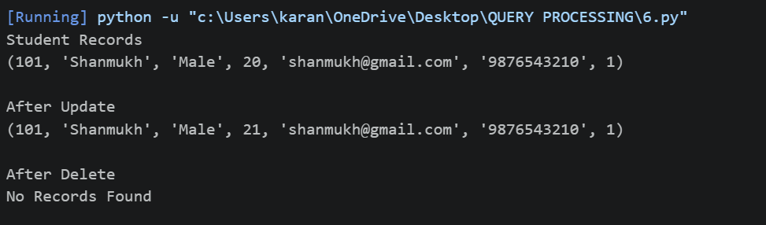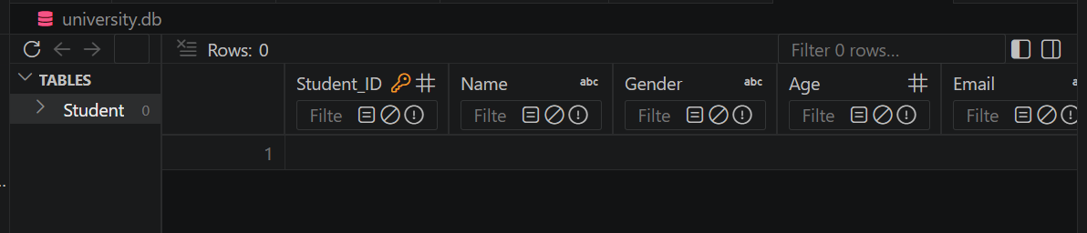

Scenario 2: Hospital Patient Record Management System
A multi-specialty hospital receives thousands of patients every month. Currently, patient records are maintained manually, making it difficult to track patient history, doctor consultations, prescriptions, laboratory tests, and billing information. The hospital management wants a database-driven application that can store patient details, doctor information, appointments, treatment records, and payment details. Each patient may visit multiple doctors over time, and doctors may consult many patients. Laboratory tests and prescriptions must also be linked to patient records. The system should provide quick access to patient histories and generate reports on disease trends and doctor workloads. Design a relational database schema for this system and use Python SQL libraries to connect to the database and manage patient information efficiently.
Code:
import mysql.connector
from mysql.connector import Error
try:
# Connect to MySQL
conn = mysql.connector.connect(
host="127.0.0.1",
user="root",
password="",
database="hospital_db",
port=3306
)
if conn.is_connected():
print("Connected to MySQL Successfully")
cursor = conn.cursor()
cursor.execute("""
CREATE TABLE IF NOT EXISTS Patient(
PatientID INT PRIMARY KEY,
PatientName VARCHAR(50),
Age INT,
Gender VARCHAR(10),
Disease VARCHAR(50)
)
""")
cursor.execute("""
CREATE TABLE IF NOT EXISTS Doctor(
DoctorID INT PRIMARY KEY,
DoctorName VARCHAR(50),
Specialization VARCHAR(50)
)
""")
cursor.execute("""
CREATE TABLE IF NOT EXISTS Appointment(
AppointmentID INT PRIMARY KEY,
PatientID INT,
DoctorID INT,
AppointmentDate DATE,
FOREIGN KEY (PatientID) REFERENCES Patient(PatientID),
FOREIGN KEY (DoctorID) REFERENCES Doctor(DoctorID)
)
""")
cursor.execute("""
CREATE TABLE IF NOT EXISTS Treatment(
TreatmentID INT PRIMARY KEY,
PatientID INT,
Prescription VARCHAR(100),
LabTest VARCHAR(100),
FOREIGN KEY (PatientID) REFERENCES Patient(PatientID)
)
""")
cursor.execute("""
CREATE TABLE IF NOT EXISTS Payment(
PaymentID INT PRIMARY KEY,
PatientID INT,
Amount DECIMAL(10,2),
PaymentStatus VARCHAR(20),
FOREIGN KEY (PatientID) REFERENCES Patient(PatientID)
)
""")
cursor.execute("DELETE FROM Payment")
cursor.execute("DELETE FROM Treatment")
cursor.execute("DELETE FROM Appointment")
cursor.execute("DELETE FROM Doctor")
cursor.execute("DELETE FROM Patient")
cursor.execute("INSERT INTO Patient VALUES (101,'Ramesh',45,'Male','Fever')")
cursor.execute("INSERT INTO Patient VALUES (102,'Priya',30,'Female','Diabetes')")
cursor.execute("INSERT INTO Doctor VALUES (201,'Dr.Kumar','General')")
cursor.execute("INSERT INTO Doctor VALUES (202,'Dr.Anita','Diabetologist')")
cursor.execute("INSERT INTO Appointment VALUES (1,101,201,'2026-07-14')")
cursor.execute("INSERT INTO Appointment VALUES (2,102,202,'2026-07-15')")
cursor.execute("INSERT INTO Treatment VALUES (1,101,'Paracetamol','Blood Test')")
cursor.execute("INSERT INTO Treatment VALUES (2,102,'Insulin','Sugar Test')")
cursor.execute("INSERT INTO Payment VALUES (1,101,500.00,'Paid')")
cursor.execute("INSERT INTO Payment VALUES (2,102,1200.00,'Pending')")
conn.commit()
print("\nPatient Records")
cursor.execute("SELECT * FROM Patient")
for row in cursor.fetchall():
print(row)
cursor.execute("""
UPDATE Patient
SET Disease='Viral Fever'
WHERE PatientID=101
""")
conn.commit()
print("\nAfter Update")
cursor.execute("SELECT * FROM Patient")
for row in cursor.fetchall():
print(row)
cursor.execute("DELETE FROM Patient WHERE PatientID=102")
conn.commit()

print("\nAfter Delete")
cursor.execute("SELECT * FROM Patient")
for row in cursor.fetchall():
print(row)
except Error as e:
print("Error:", e)
finally:
if 'conn' in locals() and conn.is_connected():
cursor.close()
conn.close()
print("\nMySQL Connection Closed")

output:
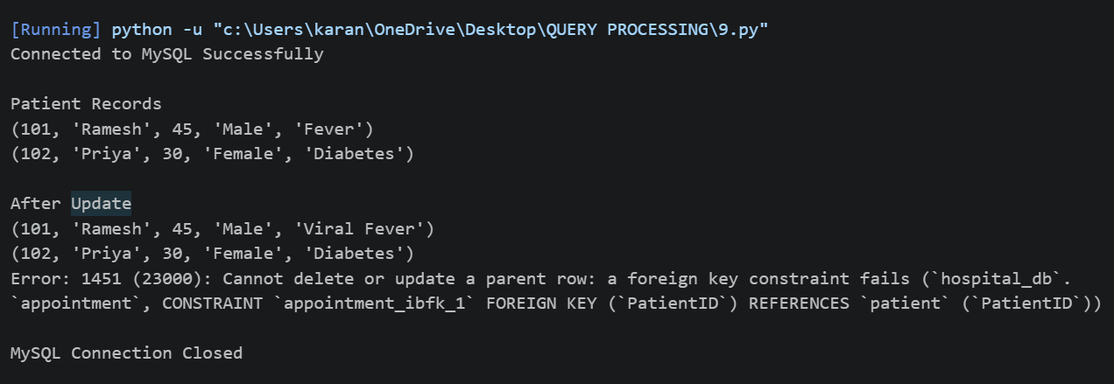

Scenario 3: E-Commerce Online Shopping Platform
An online shopping company sells products across different categories such as electronics, clothing, books, and household items. Customers create accounts, browse products, place orders, and make online payments. Each order may contain multiple products, and inventory levels must be updated automatically after each purchase. The company also wants to track customer reviews and ratings for products. The management requires reports on top-selling products, customer purchase patterns, and monthly revenue. Analyze the business requirements and design a database containing tables for customers, products, orders, payments, and reviews. Establish relationships among the tables and develop Python programs to perform database connectivity and CRUD operations.
Code:
import mysql.connector
from mysql.connector import Error
try:
conn = mysql.connector.connect(
host="127.0.0.1",
user="root",
password="",
database="ecommerce_db",
port=3306
)
if conn.is_connected():
print("Connected to MySQL Successfully")

cursor = conn.cursor()
cursor.execute("""
CREATE TABLE IF NOT EXISTS Customer(
CustomerID INT PRIMARY KEY,
CustomerName VARCHAR(50),
Email VARCHAR(50),
Phone VARCHAR(15)
)
""")
cursor.execute("""
CREATE TABLE IF NOT EXISTS Product(
ProductID INT PRIMARY KEY,
ProductName VARCHAR(50),
Category VARCHAR(50),
Price DECIMAL(10,2),
Stock INT
)
""")
cursor.execute("""
CREATE TABLE IF NOT EXISTS Orders(
OrderID INT PRIMARY KEY,
CustomerID INT,
OrderDate DATE,
TotalAmount DECIMAL(10,2),
FOREIGN KEY (CustomerID) REFERENCES Customer(CustomerID)
)
""")
cursor.execute("""
CREATE TABLE IF NOT EXISTS Payment(
PaymentID INT PRIMARY KEY,
OrderID INT,
PaymentMethod VARCHAR(30),
PaymentStatus VARCHAR(20),
FOREIGN KEY (OrderID) REFERENCES Orders(OrderID)
)
""")
cursor.execute("""
CREATE TABLE IF NOT EXISTS Review(
ReviewID INT PRIMARY KEY,
CustomerID INT,
ProductID INT,
Rating INT,
ReviewText VARCHAR(100),
FOREIGN KEY (CustomerID) REFERENCES Customer(CustomerID),
FOREIGN KEY (ProductID) REFERENCES Product(ProductID)
)
""")
cursor.execute("DELETE FROM Review")
cursor.execute("DELETE FROM Payment")
cursor.execute("DELETE FROM Orders")
cursor.execute("DELETE FROM Product")
cursor.execute("DELETE FROM Customer")
cursor.execute("INSERT INTO Customer VALUES (101,'Rahul','rahul@gmail.com','9876543210')")
cursor.execute("INSERT INTO Customer VALUES (102,'Priya','priya@gmail.com','9876543211')")
cursor.execute("INSERT INTO Product VALUES (201,'Laptop','Electronics',55000,10)")
cursor.execute("INSERT INTO Product VALUES (202,'Book','Books',500,25)")
cursor.execute("INSERT INTO Orders VALUES (301,101,'2026-07-14',55000)")
cursor.execute("INSERT INTO Orders VALUES (302,102,'2026-07-15',500)")
cursor.execute("INSERT INTO Payment VALUES (401,301,'UPI','Paid')")
cursor.execute("INSERT INTO Payment VALUES (402,302,'Card','Pending')")

cursor.execute("INSERT INTO Review VALUES (501,101,201,5,'Excellent')")
cursor.execute("INSERT INTO Review VALUES (502,102,202,4,'Good Book')")

cursor.execute("UPDATE Product SET Stock=Stock-1 WHERE ProductID=201")
cursor.execute("UPDATE Product SET Stock=Stock-1 WHERE ProductID=202")
conn.commit()
print("\nCustomer Records")
cursor.execute("SELECT * FROM Customer")
for row in cursor.fetchall():
print(row)
cursor.execute("""
UPDATE Customer
SET Phone='9999999999'
WHERE CustomerID=101
""")
conn.commit()
print("\nAfter Update")
cursor.execute("SELECT * FROM Customer")
for row in cursor.fetchall():
print(row)
cursor.execute("DELETE FROM Customer WHERE CustomerID=102")
conn.commit()
print("\nAfter Delete")
cursor.execute("SELECT * FROM Customer")
for row in cursor.fetchall():
print(row)
except Error as e:
print("Error:", e)
finally:
if 'conn' in locals() and conn.is_connected():
cursor.close()
conn.close()
print("\nMySQL Connection Closed")
Output:
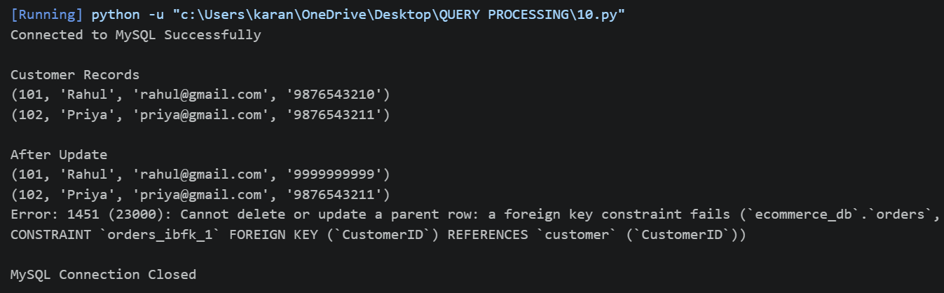

Scenario 4: Library Management System
A large academic library manages thousands of books, journals, magazines, and digital resources. Students and faculty members borrow and return books regularly. The current manual system often results in misplaced records and inaccurate tracking of issued books. The library wants to automate its operations by maintaining information about books, authors, publishers, members, and transactions. A member may borrow multiple books, and a book may be issued to different members over time. The system should also calculate fines for overdue books and generate inventory reports. Design an efficient database schema and implement database connectivity using Python to manage book records and member transactions.
Code:
import sqlite3
conn = sqlite3.connect("library.db")
cursor = conn.cursor()
cursor.execute("""
CREATE TABLE IF NOT EXISTS Books(
Book_ID INTEGER PRIMARY KEY,
Book_Name TEXT,
Author TEXT,
Publisher TEXT,
Price REAL
)
""")
conn.commit()
print("Books Table Created Successfully")
print("\nTables in Database")
cursor.execute("SELECT name FROM sqlite_master WHERE type='table';")
for table in cursor.fetchall():
print(table[0])
cursor.execute("""
INSERT INTO Books
VALUES(101,'Python Programming','Guido','Pearson',550)
""")
cursor.execute("""
INSERT INTO Books
VALUES(102,'Database Systems','Navathe','McGraw Hill',700)
""")
cursor.execute("""
INSERT INTO Books
VALUES(103,'Operating Systems','Galvin','Wiley',650)
""")
conn.commit()
print("\nRecords Inserted Successfully")
print("\nBook Records")
cursor.execute("SELECT * FROM Books")
for row in cursor.fetchall():
print(row)
cursor.execute("""
UPDATE Books
SET Price=600
WHERE Book_ID=101
""")
conn.commit()
print("\nRecord Updated Successfully")
print("\nAfter Update")
cursor.execute("SELECT * FROM Books")
for row in cursor.fetchall():
print(row)
print("\nSearch Result")
cursor.execute("""
SELECT * FROM Books
WHERE Author='Guido'
""")
for row in cursor.fetchall():
print(row)
cursor.execute("""
DELETE FROM Books
WHERE Book_ID=103
""")
conn.commit()
print("\nRecord Deleted Successfully")
print("\nFinal Records")
cursor.execute("SELECT * FROM Books")
for row in cursor.fetchall():
print(row)
conn.close()
print("\nDatabase Closed Successfully")
Output:
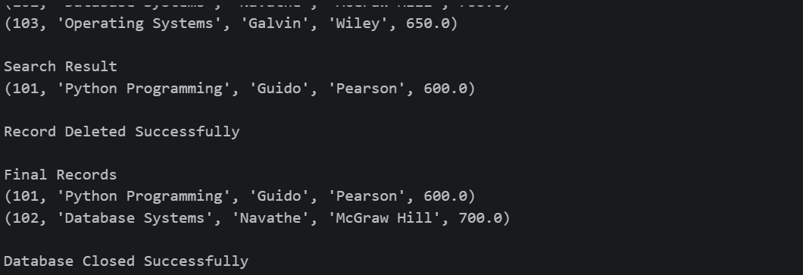
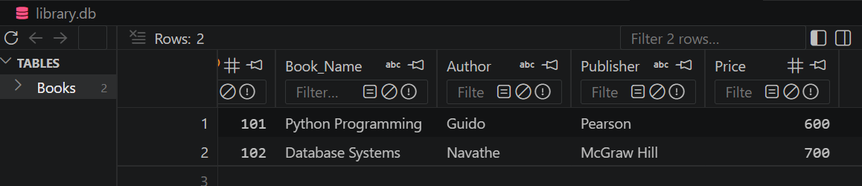

Scenario 8: Employee Payroll Management System
A manufacturing company employs hundreds of workers and administrative staff. The Human Resources department currently manages employee information and salary calculations using spreadsheets, which often leads to payroll errors. The company wants a database-driven payroll system to store employee details, department information, attendance records, salary structures, and tax deductions. Each employee belongs to a department, and payroll must be generated monthly based on attendance and salary components. Design a normalized database schema and create a Python application that performs employee management and payroll processing using database connectivity.
Code:
import sqlite3
conn = sqlite3.connect("payroll.db")
cursor = conn.cursor()
cursor.execute("""
CREATE TABLE IF NOT EXISTS Employee(
Employee_ID INTEGER PRIMARY KEY,
Employee_Name TEXT,
Department TEXT,
Designation TEXT,
Salary REAL
)
""")
conn.commit()
print("Employee Table Created Successfully!")
print("\nTables in Database:")
cursor.execute("SELECT name FROM sqlite_master WHERE type='table';")
for table in cursor.fetchall():
print(table[0])
cursor.execute("""
INSERT INTO Employee
VALUES(101,'Rahul','Production','Manager',50000)
""")
cursor.execute("""
INSERT INTO Employee
VALUES(102,'Priya','HR','HR Executive',40000)
""")
cursor.execute("""
INSERT INTO Employee
VALUES(103,'Arun','Finance','Accountant',45000)
""")
conn.commit()
print("\nRecords Inserted Successfully!")
print("\nEmployee Records")
cursor.execute("SELECT * FROM Employee")
for row in cursor.fetchall():
print(row)
cursor.execute("""
UPDATE Employee
SET Salary=55000
WHERE Employee_ID=101
""")
conn.commit()
print("\nRecord Updated Successfully!")
print("\nAfter Update")
cursor.execute("SELECT * FROM Employee")
for row in cursor.fetchall():
print(row)
print("\nSearch Result")
cursor.execute("""
SELECT * FROM Employee
WHERE Department='HR'
""")
for row in cursor.fetchall():
print(row)
cursor.execute("""
DELETE FROM Employee
WHERE Employee_ID=103
""")
conn.commit()
print("\nRecord Deleted Successfully!")
print("\nFinal Records")
cursor.execute("SELECT * FROM Employee")
for row in cursor.fetchall():
print(row)
conn.close()
print("\nDatabase Closed Successfully!")
Output:
